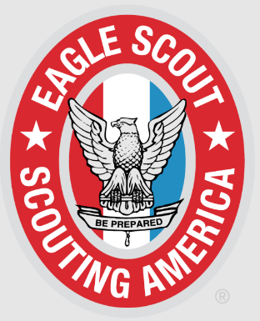
Eagles Scout Name: ________________________________________________
Parent Name(s): ___________________________________________________
Unit #: ___________________________________________________________
High School: ______________________________________________________
Future Plans: ______________________________________________________
Describe briefly your Eagle Scout Service Project and how many hours to complete:
______________________________________________________________________________________
______________________________________________________________________________________
______________________________________________________________________________________
______________________________________________________________________________________
______________________________________________________________________________________
______________________________________________________________________________________
Please have a photo (JPEG format) of the Eagle Scout in uniform. This form can be completed online by going to http://thonline.com/eaglescout . When using the online form, once submitted, this information is automatically sent to all the newspapers below. If you have any questions for any of the newspapers listed, here are their phone numbers and email addresses.
- Dubuque Telegraph Herald: michelle.allen@thmedia.com Ph: 563-588-5637
- Dyersville Commercial & Cascade Pioneer: dceditor@wcinet.com Ph: 563-875-7131
- Bellevue Herald Leader: bhleader@bellevueheraldleader.com Ph: 563-872-4159
- Galena Gazette: hdickerson@galgazette.com Ph: 815-777-0019 or 1-800-373-6397

Example of what is needed:
John A. Scout, member of Scouts America Troop 135, St. Joseph’s Catholic Church, Key West, Iowa, and Order of the Arrow, Timmeu Lodge, achieved the rank of Eagle Scout. To earn his award he removed overgrown bushes and shrubs, along with aged railroad ties from the flagpole area at the Swiss Valley Park Campground. He then landscaped the area and constructed a raised planter, added perennials and solar light. 270 hours went into completing his project at a cost of $900. Fetzer, son of Ron and Josie Scout, of Dubuque, is currently a senior at Dubuque Senior High School.
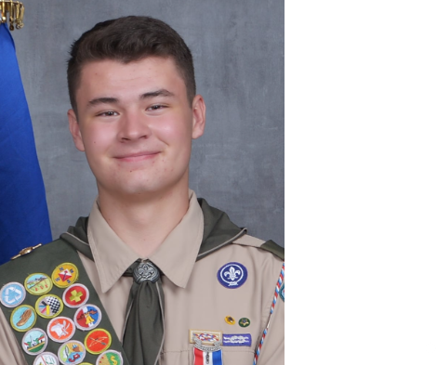
Please submit no later than 30 days after you
receive your Eagle Scout Badge.

